**NAME: JEEVITHA.S-192324020**

**DATA BASE MANAGEMENT SYSTEM FOR WEB APPLICATION(CSA0555)**

**ASSIGNMENT-26 IN,OUT,INOUT**

IN :

CREATE OR REPLACE PROCEDURE raise_salary

(employee_id IN emp.employee_id%TYPE,

p_percent IN NUMBER)

IS

BEGIN

UPDATE emp

SET salary = salary * (1 + p_percent/100)

WHERE employee_id = employee_id;

END raise_salary;

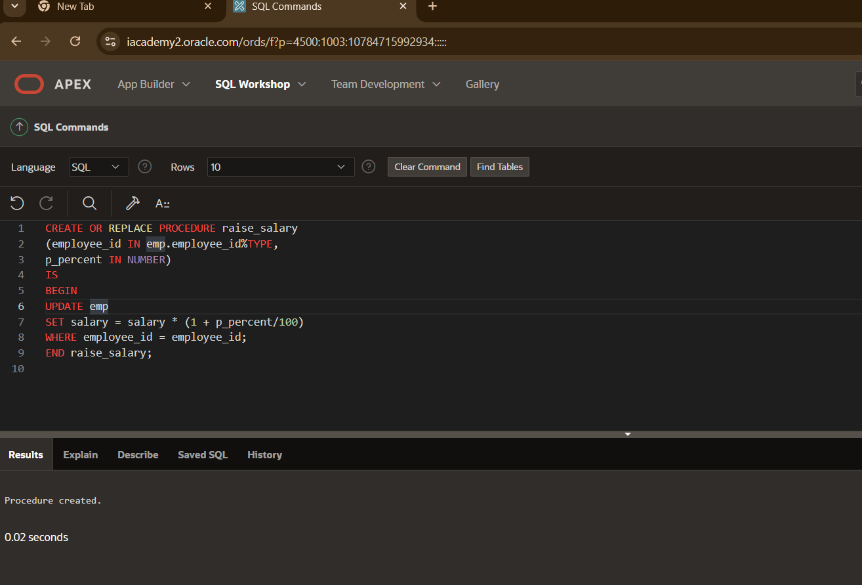

begin

raise_salary(274,10);

End;

select*from employeees;

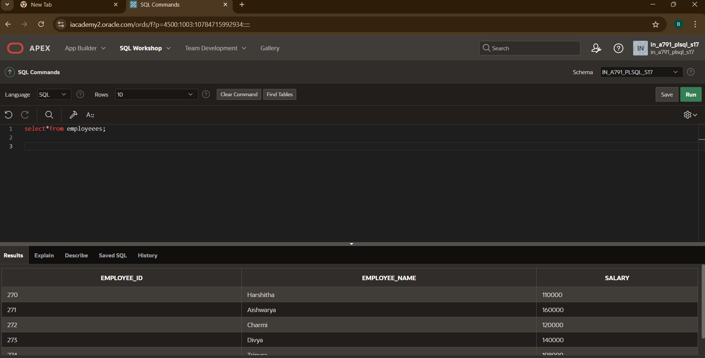

OUT:

CREATE OR REPLACE PROCEDURE query_emp

(p_id IN employeees.employee_id%TYPE,

p_name OUT employeees.employee_name%TYPE,

p_salary OUT employeees.salary%TYPE) IS

BEGIN

SELECT employee_name, salary INTO p_name, p_salary

FROM employeees

WHERE employee_id = p_id;

END query_emp;

DECLARE

a_emp_name employeees.employee_name%TYPE;

a_emp_sal employeees.salary%TYPE;

BEGIN

query_emp(271, a_emp_name, a_emp_sal);

DBMS_OUTPUT.PUT_LINE('Name: ' || a_emp_name);

DBMS_OUTPUT.PUT_LINE('Salary: ' || a_emp_sal);

END;

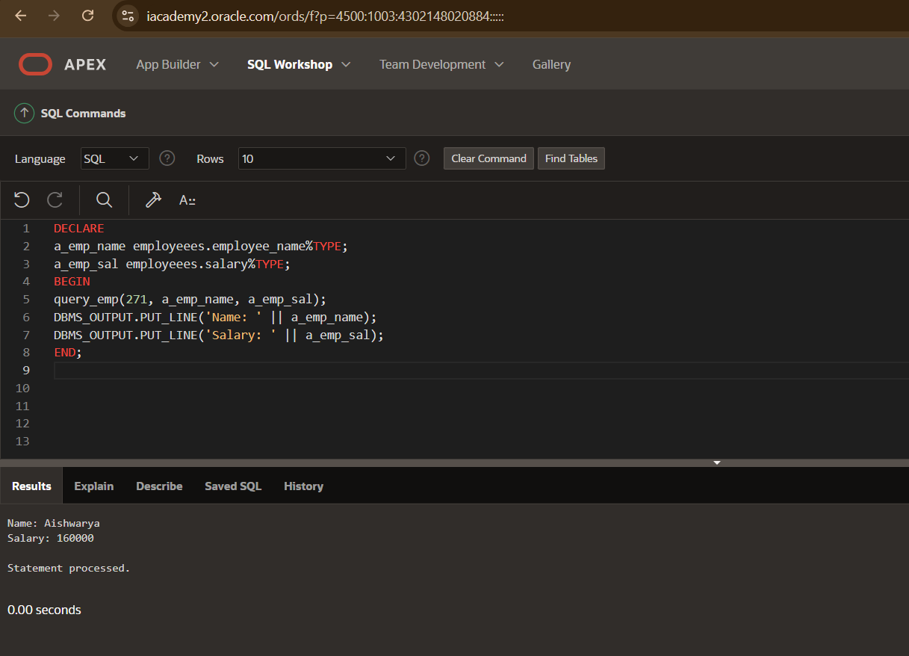

IN OUT:

CREATE OR REPLACE PROCEDURE update_employee_salary (

p_emp_id IN employeees.employee_id%TYPE,

p_new_salary IN OUT employeees.salary%TYPE

) IS

BEGIN

UPDATE employeees

SET salary = p_new_salary

WHERE employee_id = p_emp_id;

SELECT salary INTO p_new_salary

FROM employeees

WHERE employee_id = p_emp_id;

COMMIT;

END update_employee_salary;

/

DECLARE

l_emp_id employeees.employee_id%TYPE := 270;

l_new_salary employeees.salary%TYPE := 110000;

BEGIN

update_employee_salary(l_emp_id, l_new_salary);

DBMS_OUTPUT.PUT_LINE('Updated Salary: ' || l_new_salary);

END;

/

